EX 10: IMPLEMENT THE MODIFIED SYSTEM AND TEST IT FOR VARIOUS SCENARIOS

STEP 1: INTEGRATE DESIGN PATTERNS
We applied key design patterns to the Java-based Exam Registration System to enhance modularity and maintainability:
- Layered Architecture: Separate presentation (GUI), business logic (registration rules), and data access layers for better separation of concerns.
- Client-Server Pattern: The Java Swing-based client communicates with the MySQL database server for registration data handling.
- Repository Pattern: Abstracts and centralizes database CRUD operations related to exam registrations.
IMPLEMENTED FEATURES:
- Clean separation of UI, registration logic, and database access.
- Efficient communication between the client GUI and database server.
- Repository interface to simplify and unify database operations.

STEP 2: TESTING
Regression Testing: Ensure that integrating design patterns did not break existing functionalities like student registration, viewing, and deletion.
TEST PLAN:
Test Case ID | Test Scenario | Expected Result | Status
TC-01 | Layered Architecture Validation | Registration logic is separate from UI and DB | ✅ Pass
TC-02 | Client-Server Connectivity | Client can connect and perform registration inserts | ✅ Pass
TC-03 | Repository Insert Operation | Data inserted via repository abstraction | ✅ Pass
TC-04 | Registration Data Retrieval | Retrieval occurs without DB logic in UI | ✅ Pass
TC-05 | Regression Testing | All pre-existing features work post modifications | ✅ Pass
Testing Tools Used:
- JUnit: For unit testing business logic related to registration rules.
- Manual Testing: GUI interactions and database integration.
- Eclipse IDE: Development and debugging support.

STEP 3: TESTING TYPES
- Unit Testing: Test registration validation logic and data integrity checks independently.
- Integration Testing: Verify database connection, DAO/repository CRUD operations, and client-server communication.
- Black Box Testing: Validate overall system behavior, including registration success/failure for various inputs, boundary conditions, and error handling.

1.UNIT TESTING:
import org.junit.jupiter.api.*;
import java.util.List;
import static org.junit.jupiter.api.Assertions.*;
public class ExamServiceTest {
private ExamService service;
@BeforeEach
public void setUp() {
service = new ExamService();
}
@Test
public void testRegisterExam() {
ExamRegistration exam = new ExamRegistration(1001, "Test User", "REG123", "Maths", "2025-06-10");
boolean result = service.registerExam(exam);
assertTrue(result, "Registration should return true");
}
@Test
public void testViewAll() {
List<ExamRegistration> exams = service.viewAll();
assertNotNull(exams, "ViewAll should not return null");
assertTrue(exams.size() >= 0, "List size should be zero or more");
}
@Test
public void testDeleteExam() {
boolean deleted = service.deleteExam(1001); // same ID as in register test
assertTrue(deleted, "Delete should return true if ID existed");
}
@Test
public void testDeleteNonExistentExam() {
boolean deleted = service.deleteExam(9999); // assuming this ID doesn't exist
assertFalse(deleted, "Should return false for non-existent ID");
}
}

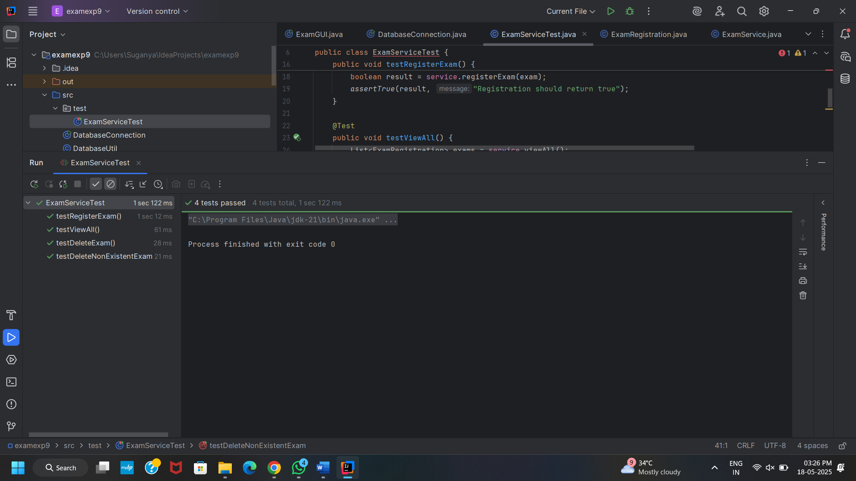
2. WHITE BOX TESTING
import org.junit.jupiter.api.*;
import static org.junit.jupiter.api.Assertions.*;
public class Validationtest {
@Test
public void testEmptyStudentName() {
ExamRegistration ex = new ExamRegistration(1, "", "REG123", "Maths", "2025-06-10");
assertEquals("", ex.getStudentName(), "Student name should be empty");
}
@Test
public void testIDBoundary() {
ExamRegistration ex = new ExamRegistration(0, "User", "R1", "Sci", "2025-01-01");
assertEquals(0, ex.getId(), "ID should be allowed at 0 (check logic if disallowed)");
}
}
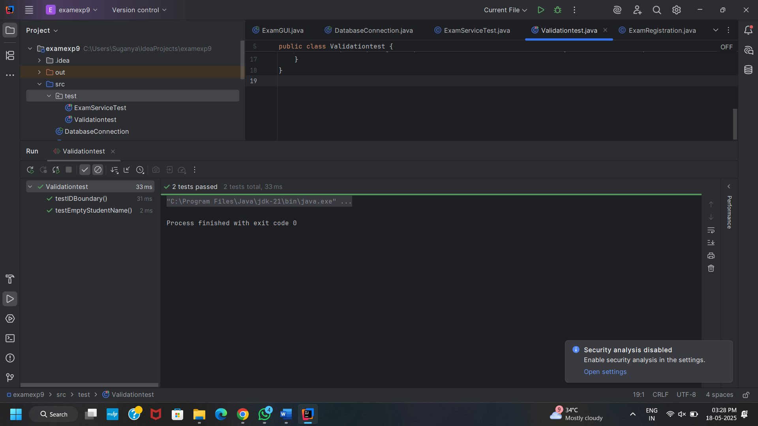
3.BLACK BOX TESTING
import org.junit.jupiter.api.*;
import static org.junit.jupiter.api.Assertions.*;
public class BlackBoxTest {
private ExamService service;
@BeforeEach
public void setUp() {
service = new ExamService();
}
@Test
public void testRegisterWithValidInput() {
ExamRegistration exam = new ExamRegistration(2025, "Black Box", "BB123", "Physics", "2025-07-15");
assertTrue(service.registerExam(exam), "Valid data should be accepted");
}
@Test
public void testRegisterWithDuplicateID() {
ExamRegistration exam1 = new ExamRegistration(2023, "Test cA", "RA11", "Bio", "2025-05-20");
ExamRegistration exam2 = new ExamRegistration(2023, "Test cB", "RA22", "Chem", "2025-05-21");
assertTrue(service.registerExam(exam1), "First insert should succeed");
boolean result = service.registerExam(exam2); // same ID
assertFalse(result, "Duplicate ID should fail");
}
}

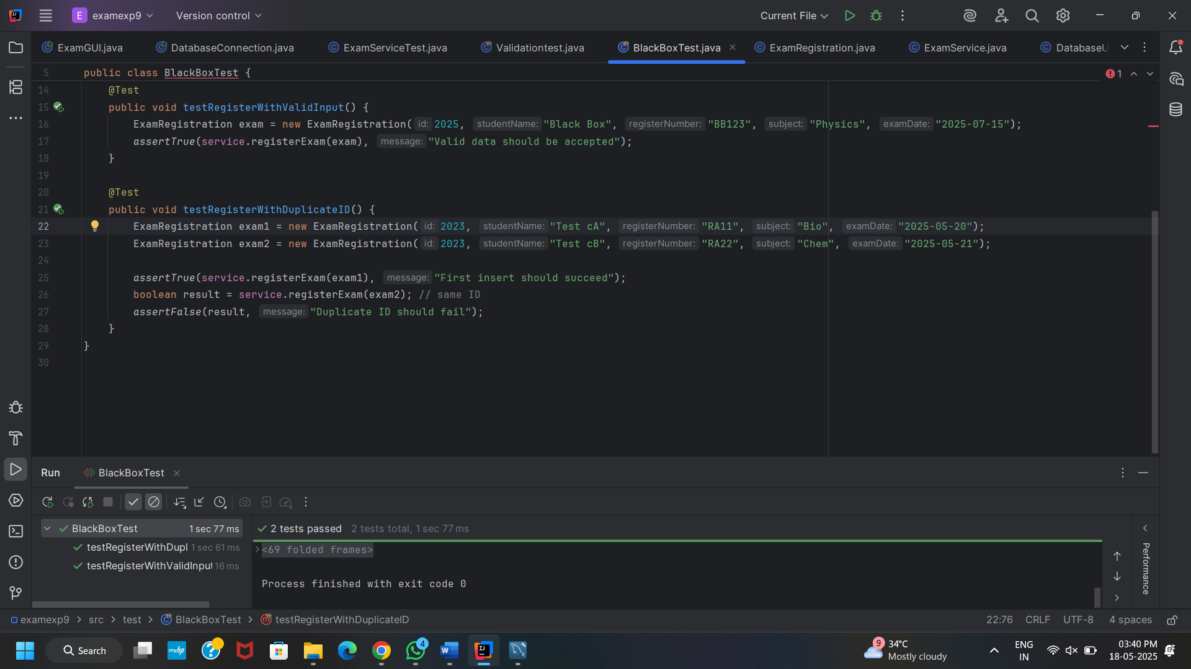
4. INTEGRATION TESTING
Integration test
import org.junit.jupiter.api.*;
import java.util.List;
import static org.junit.jupiter.api.Assertions.*;
public class IntegrationTest {
private ExamService service;
@BeforeEach
public void init() {
service = new ExamService();
}
@Test
public void testFullFlow() {
// Step 1: Register
ExamRegistration exam = new ExamRegistration(3001, "Integration User", "INT123", "CSE", "2025-08-20");
assertTrue(service.registerExam(exam), "Should register");
// Step 2: View
List<ExamRegistration> list = service.viewAll();
boolean found = false;
for (ExamRegistration e : list) {
if (e.getId() == 3001) {
found = true;
break;
}
}
assertTrue(found, "Should find the newly added registration");
assertTrue(service.deleteExam(3001), "Should delete the registered exam");
}
}

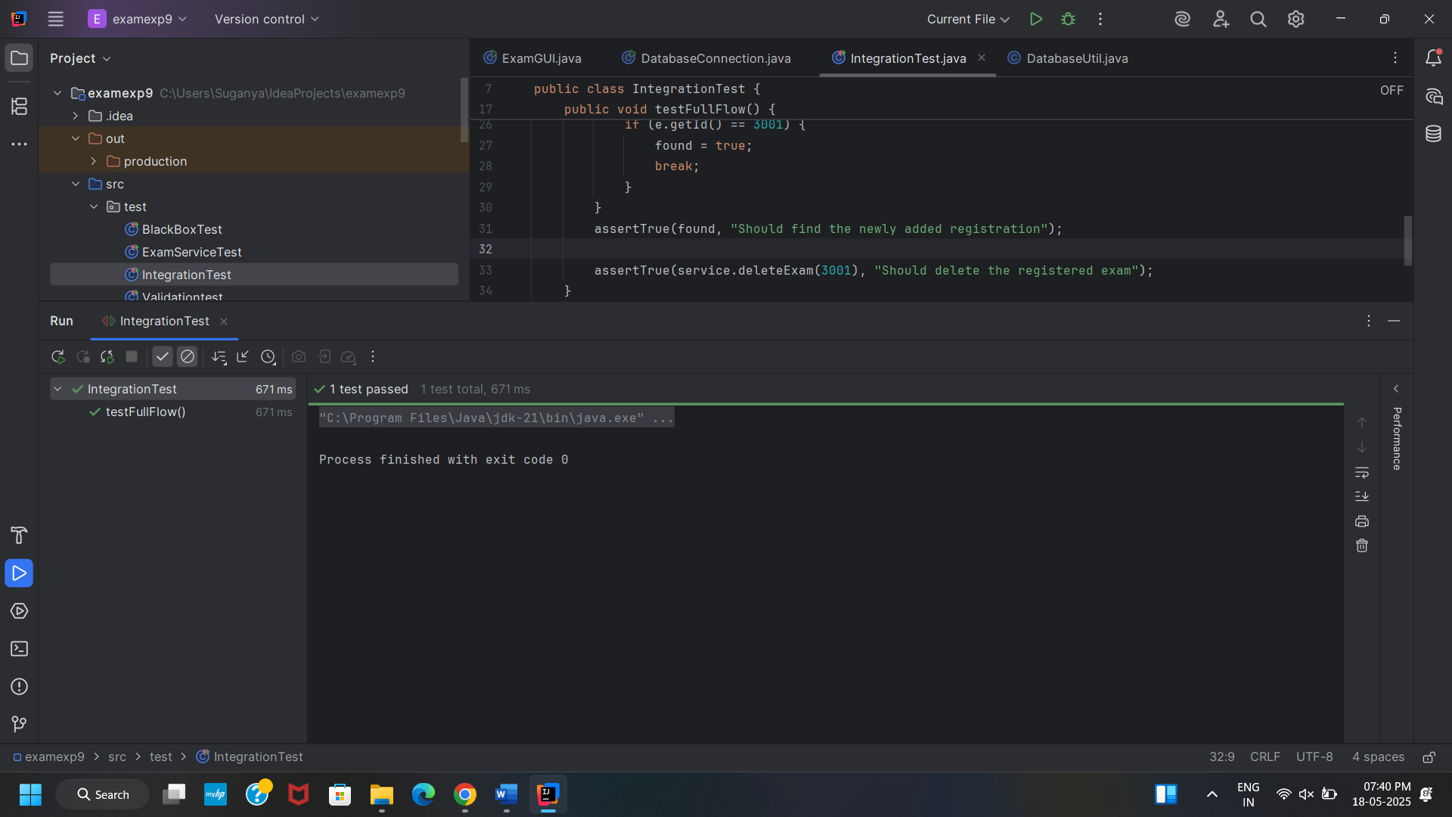
STEP 4: FINAL REPORT
SUMMARY OF MODIFICATIONS:
- Adopted Layered Architecture for better maintainability.
- Implemented Client-Server pattern for robust data handling.
- Used Repository pattern to simplify database interaction.
- Tested thoroughly with unit, integration, and regression testing.
- Resulted in a scalable, modular, and testable Exam Registration System.
Outcome:
- Successfully implemented a modular Exam Registration System using layered architecture, client-server, and repository patterns.
- Improved maintainability and scalability; future enhancements can be added with minimal impact.
- Registration workflows (add, view, delete) operate smoothly with clear separation of concerns.
- Thorough testing confirmed robustness, reliability, and data integrity.
- User-friendly GUI enables easy exam registration and management.
- System is ready for deployment in academic environments.

